Safeguarding Statement
All adults working in education and/or are part of this forum have a duty of care to protect children and young people from harm. If we become aware that a child or young person is being harmed or at risk of significant harm, in line with Keeping Children Safe in Education 2022 and Working Together to Safeguard Children, we have a duty of care to report it to the relevant statutory services.

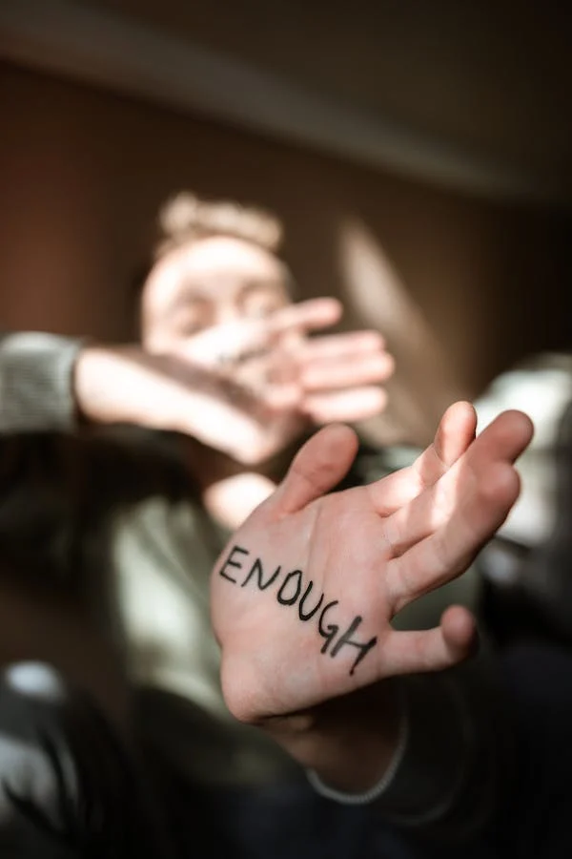

Healthy Relationships Advisory Forum for schools and Colleges
January 2023

Information Leaflet
What is the forum for?
The forum is an opportunity for schools and colleges to discuss concerns about a child or young person’s behaviour within the relationships they have. This could be friendships, personal relationships and family relationships. The aim is to prevent the concerning behaviours from developing further and becoming abusive in their adult life.
The forum is to provide the school or college with advice and strategies, signpost them to support services or help in direct work for the child. This will assist in providing the right support at an early stage and help them in their future life.
Will information about my child be shared with police or social care?
The forum panel is made up of professionals from non-statutory services. This means that police and social care are not part of this forum panel. The aim of the forum is to discuss worries about the behaviour and look at what support or advice can be shared to change the behaviour at an early stage. This may prevent behaviour getting worse and the need for involvement with statutory services.
It is important to note that there may be occasions where the discussion highlights a higher level of concern. Where there is concern about the safety of your child or any other child/adult, there would be a recommendation for a referral to children’s social care. Where there is disclosure of a criminal offence, police will be called. The aim would always be to discuss this with you as a parent/carer unless it was considered to put the child at risk of harm.
Who has information about my child?
The school obviously have information that is shared with the panel members only for the purpose of the discussion. A summary of the concern and recommendations will be held securely by the Chair and all members attending adhere to a confidentiality agreement.
If there is a social worker already linked to your child, information will be shared with them as part of our working together agreement.
Who is on the panel?
The panel is made up of
- Cath Bennett (chair) – Croydon Education Safeguarding Lead
- Fozia Drysdale – FJC
- Deborah Mitchell – Senior attendance and inclusion advisor
- Haydar Muntadhar – Prevent Manager, Culture and community safety.
- Zoe Barkhammanlow - Education Adviser Health & Wellbeing

