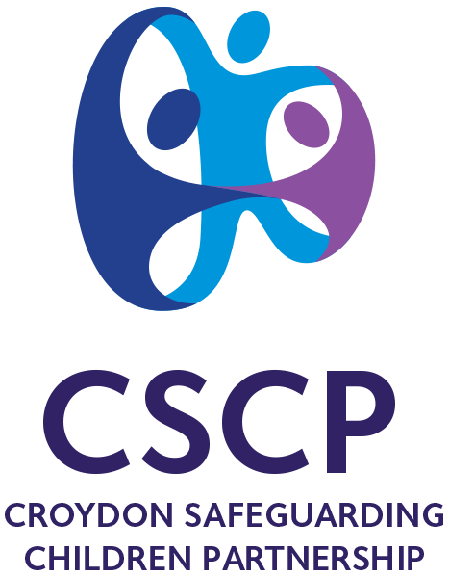

Croydon Safeguarding Children Partnership

Safeguarding Standards – Agency Name

Author: XX

For presentation to: | QIG
 | Date
Purpose | For Information/Discussion/

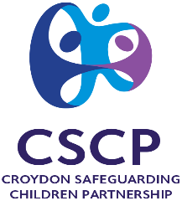

Report to: | QIG
Date of meeting:
Title of report: | Safeguarding Standards - Agency
Report author:
Item No.

- Purpose of Report
This report is the second of the 3 Executive Partner reports to demonstrate the effectiveness of the Agency Safeguarding Children Arrangements.

- Background Information
The Croydon Safeguarding partners have an equal and shared responsibility to ensure safeguarding arrangements are effective and enable:
- Children to be safeguarded and their welfare promoted
- Partner organisations and agencies to collaborate, share and co-own the vision for how to achieve improved outcomes for vulnerable children
- Organisations and agencies to challenge appropriately and hold one another to account effectively
- Early identification and analysis of new safeguarding issues and emerging threats
- Learning to be promoted and embedded in a way that local services for children and families can become more reflective and implement changes to practice
- Information to be shared effectively to facilitate more accurate and timely decision making for children and families.
To evidence and test the effectiveness of these arrangements the CSCP uses the Learning Improvement Framework. This framework helps to create a culture and practice of continuous learning and to provide a clear line of sight on what is working well and what needs improving.

Working Together 2018 sets out that these arrangements should be independently scrutinised in order to provide assurance in judging the effectiveness of the arrangements. This includes the scrutiny on the effectiveness for children and families as well as for practitioners, and how well the safeguarding partners are providing strong leadership. The CSCP has in place an Independent Scrutineer and has agreed that an independent scrutiny report should be published annually.

Enter any other relevant detail

- What action has already taken place?

Section 11 of the Children’s Act 2004 places duties on a range of organisations, agencies and individuals to ensure their functions, and any services that they contract out to others, are discharged having regard to the need to safeguard and promote the welfare of children.
http://www.workingtogetheronline.co.uk/chapters/chapter_two.html

The Section 11 Standards are still in place, however the CSCP does not routinely require sight of the self audit tool. It does however provide a Croydon specific version partners can use to self-assess their safeguarding standards.

http://croydonlcsb.org.uk/wp-content/uploads/2021/04/Section-11-Audit-Tool-v3-2021-CSCP.xlsx

you can use this tool to help you focus on where your evidence is

The CSCP are using the ‘Bedford 6 Safeguarding Standards’ as a benchmark tool. For examining effectiveness of safeguarding arrangements. Appendix A gives some more detail of how the Bedford 6 standards are reflected in the Agency Safeguarding Arrangements.

- The voice of the child, the child's experiences, parent and carers' views

Standard 3 specifically references this – see below

Enter any other relevant detail

- What difference have we made or will we make?

Knowing the gaps and challenges in our safeguarding arrangements means we can specifically target those for improvement – including ensuring the wider partnership is consulted to see where collaboration can improve safeguarding outcomes for children and families in Croydon. Training and audit activity can also be tailored accordingly.

Edit above… or enter any other relevant detail

- How has or how will the impact be evidenced?

Audit activity?
Attendance at SCRs/Learning events?
Reports/research from agency departments?

- Recommendations to CSCP

To accept this report as evidence of robust safeguarding arrangements to protect children in accordance with the requirements of the CSCP Executive Partners remit.

Enter any other relevant detail

Appendix A - Evidence to Support Agency Safeguarding Arrangements.

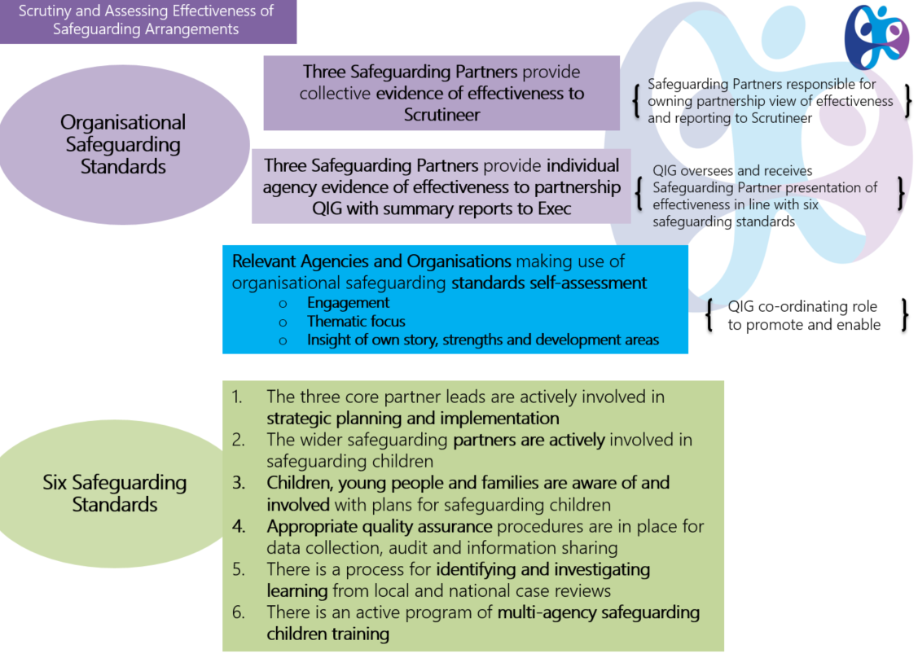

 | Standard | Evidence | RAG
1 | The Agency are actively involved in strategic planning and implementation
2 | The Agency are actively involved in safeguarding children
3 | Children and Young People are involved with plans for safeguarding children
4 | Appropriate quality assurance procedures are in place for data collection, audit and information sharing
5 | There is a process for identifying and investigating learning from local and national case reviews
6 | There is an active program of multi-agency safeguarding children training

What additional evidence can you offer to demonstrate your effectiveness to safeguard children with SEND?

Are there any specific challenges you face when safeguarding children?

Any other evidence of note?

